# SCITE – SCITEJAVA – SCITEPLUS Comparison

Case 1: Simulation Data from Simulation Tree number 0 – 40 Single Cell random picked (No Repeatable)

## SCITE:

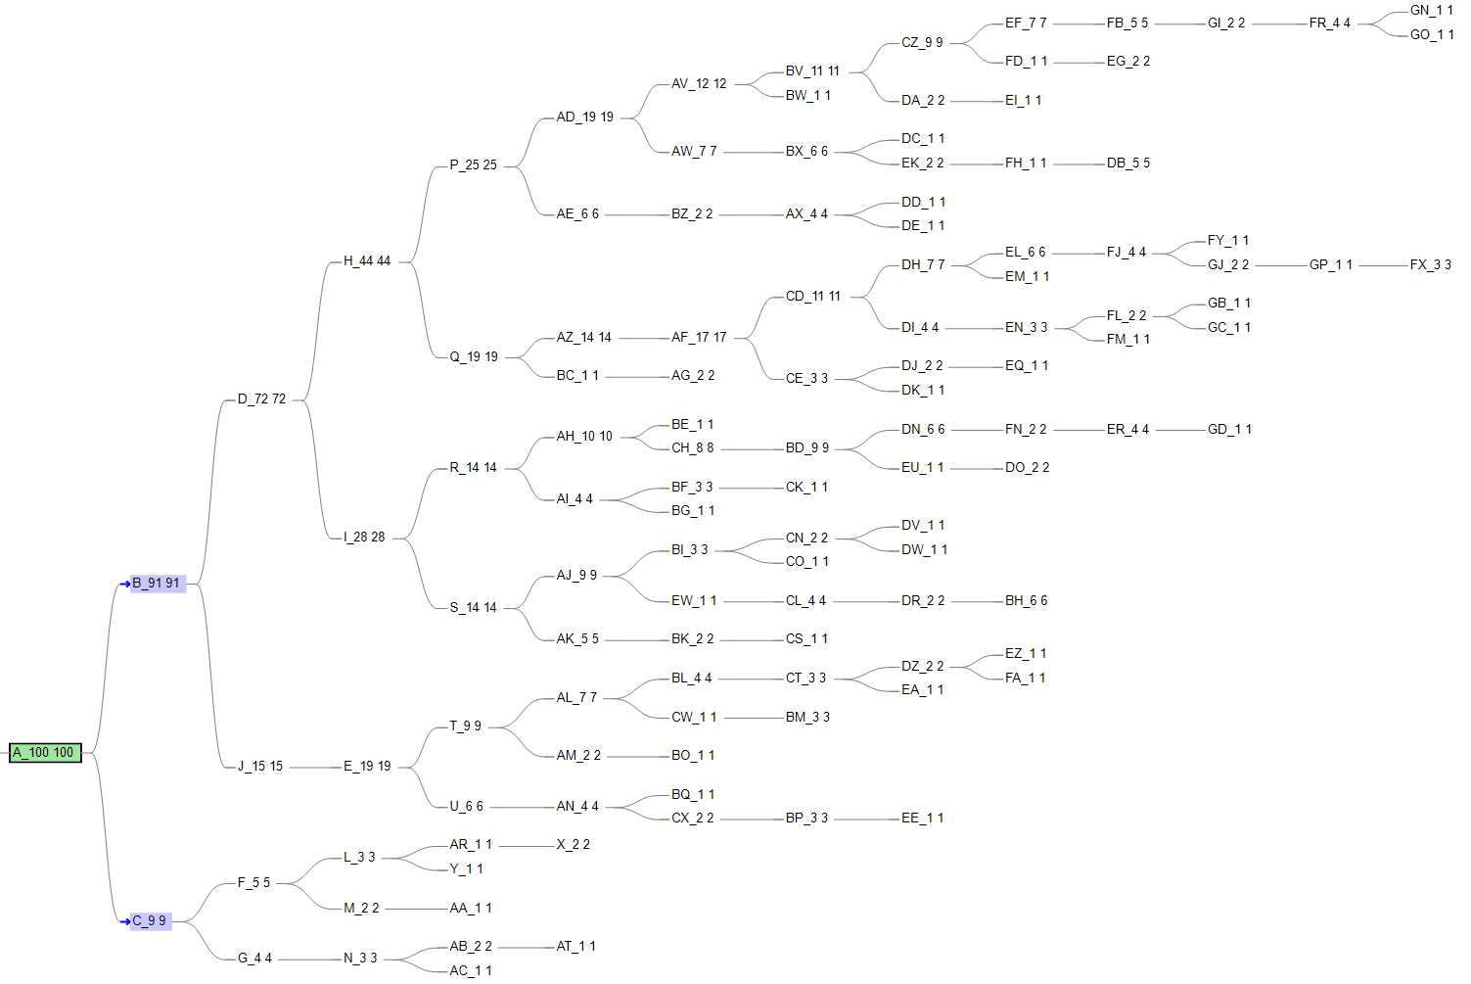

Matrix Comparison Score: 0.99698

## SCITE JAVA:

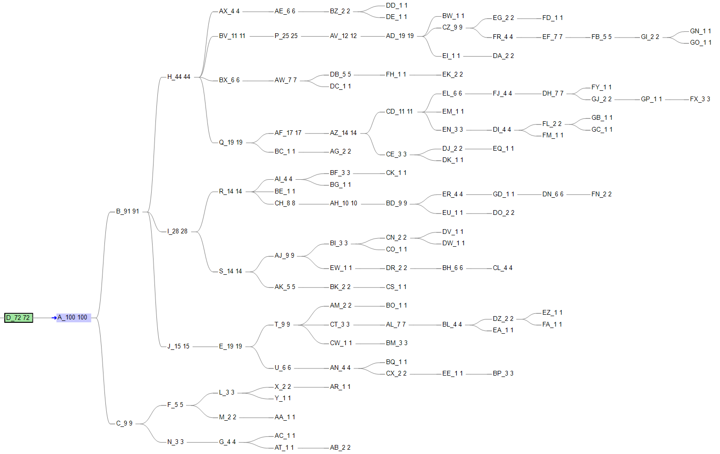

Matrix Comparison Score: 0.990735

## SCITE PLUS:

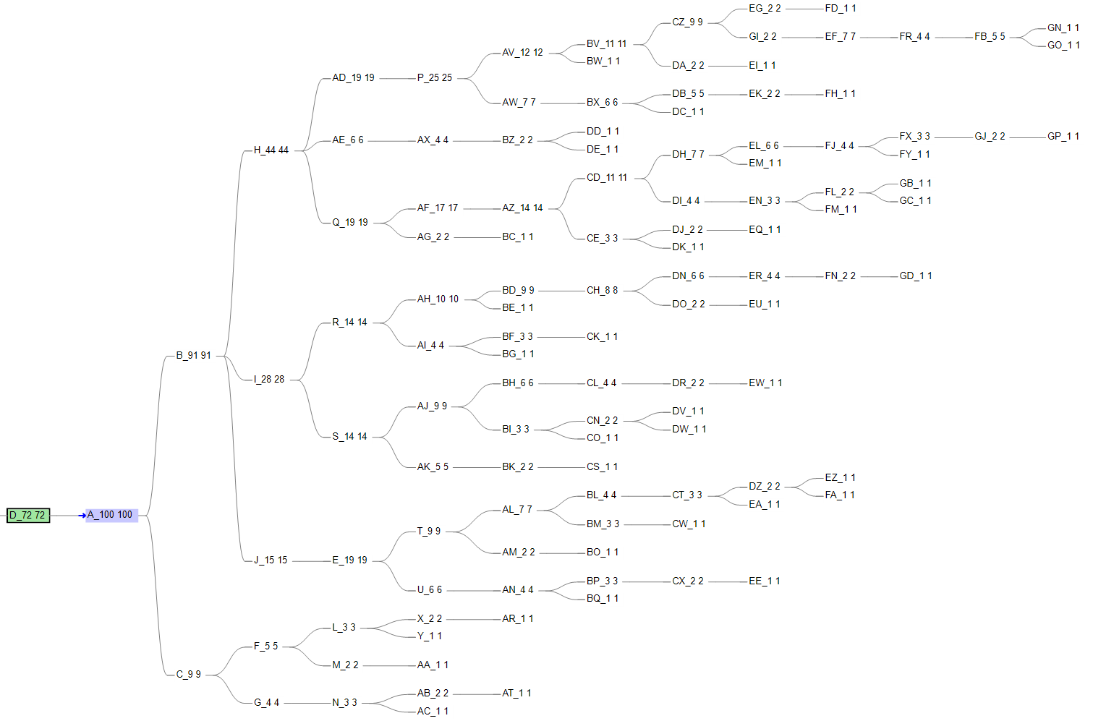

Matrix Comparison Score: 0.9961

Case 2: Simulation Data from Simulation Tree number 0 – 20 Single Cell random picked (No Repeatable)

SCITE:

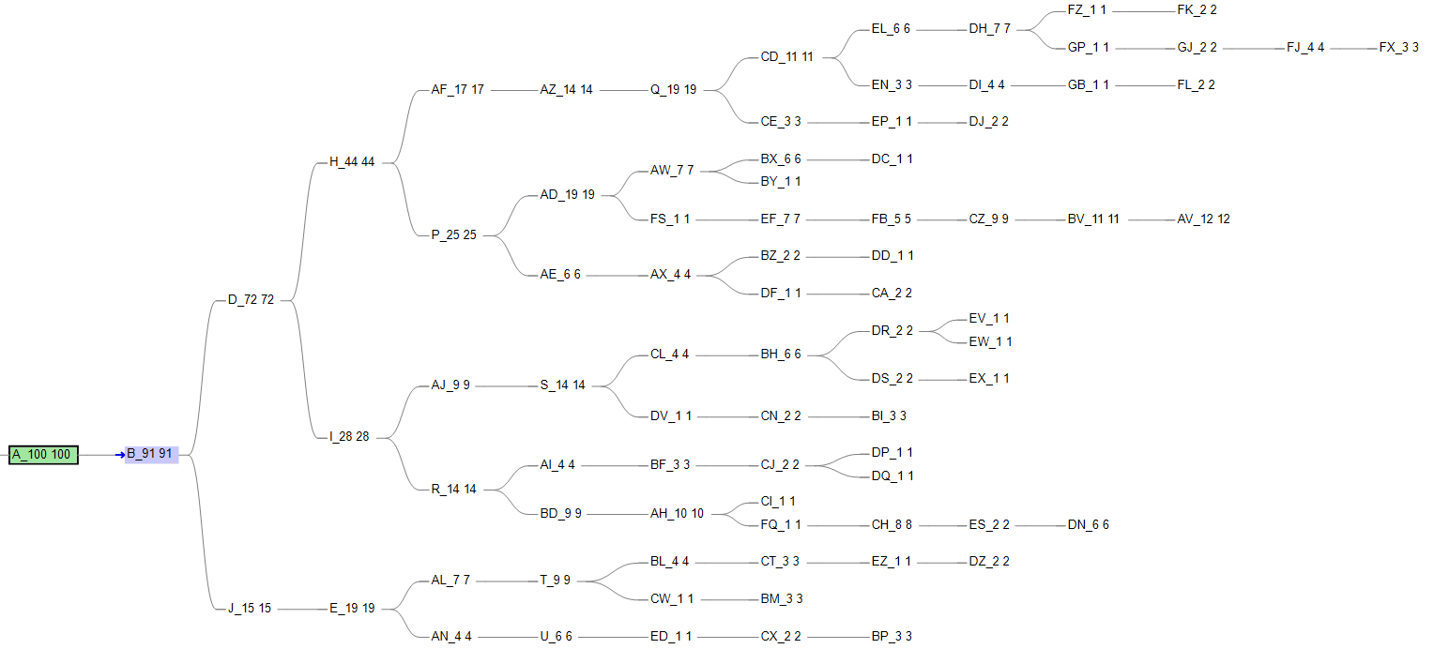

Matrix Comparison Score：0.986615

SCITE JAVA:

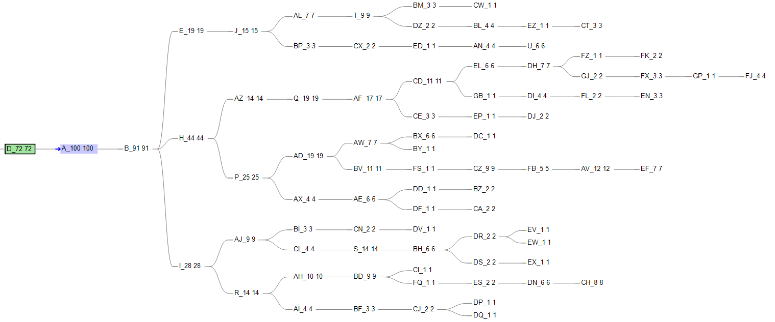

Matrix Comparison Score: 0.98364

SCITE PLUS:

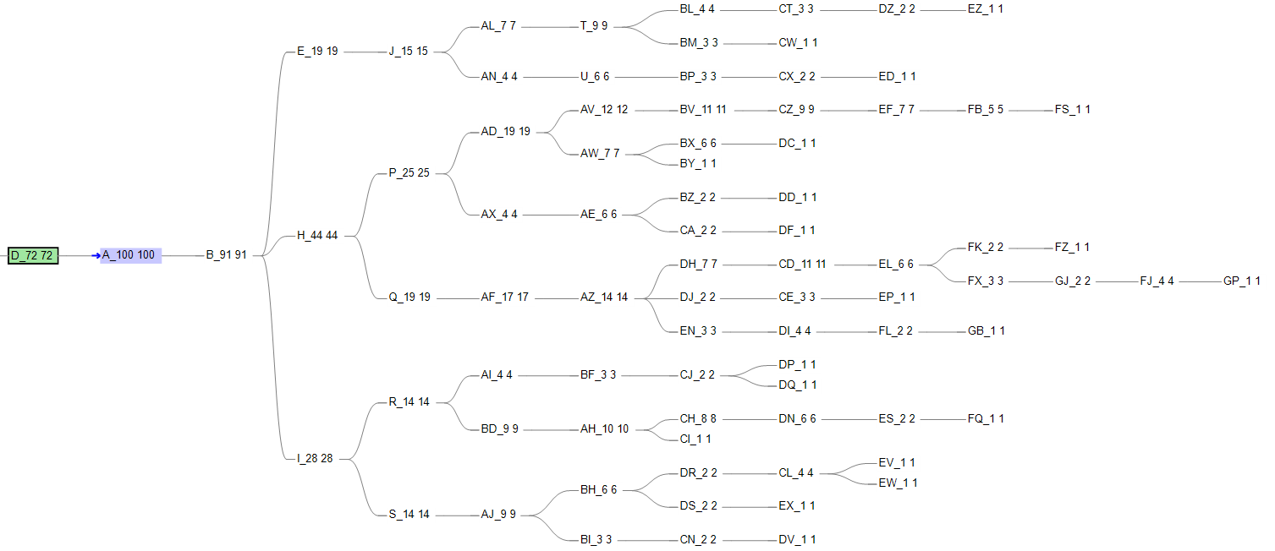

Matrix Comparison Score: 0.993307

Case 3: Simulation Data from Simulation Tree number 0 – 30 Single Cell random picked (No Repeatable)

SCITE:

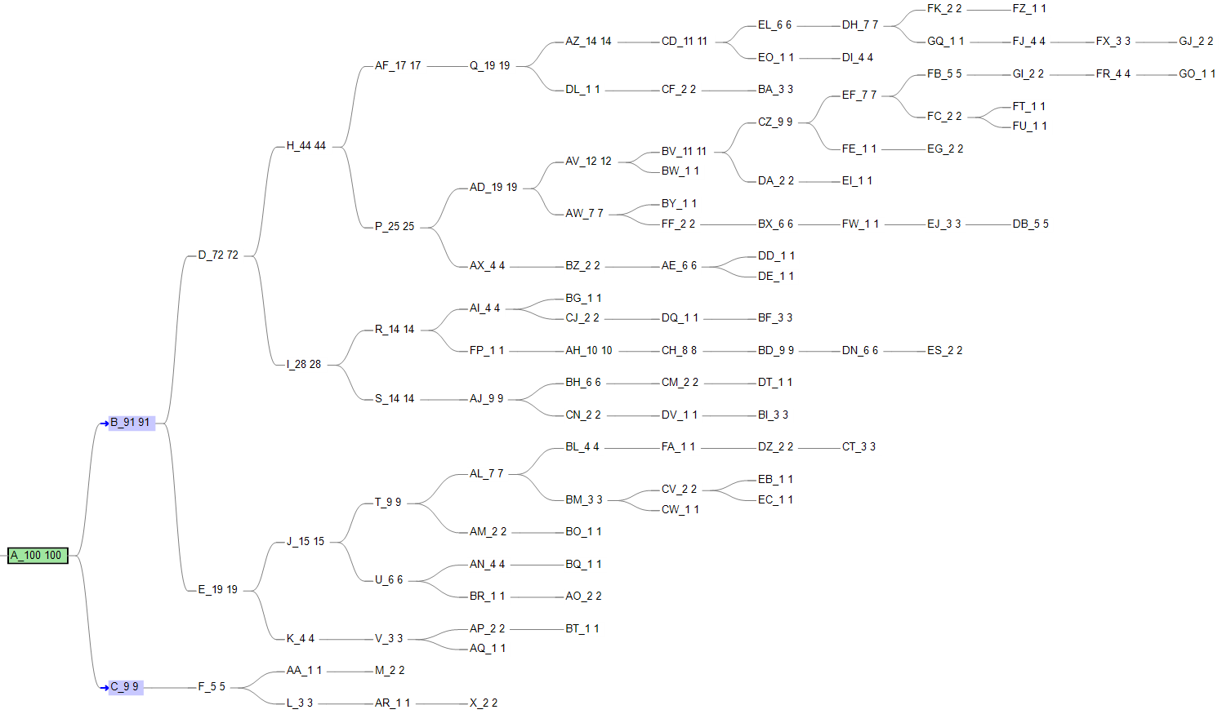

Matrix Comparison Score: 0.993528

SCITE JAVA:

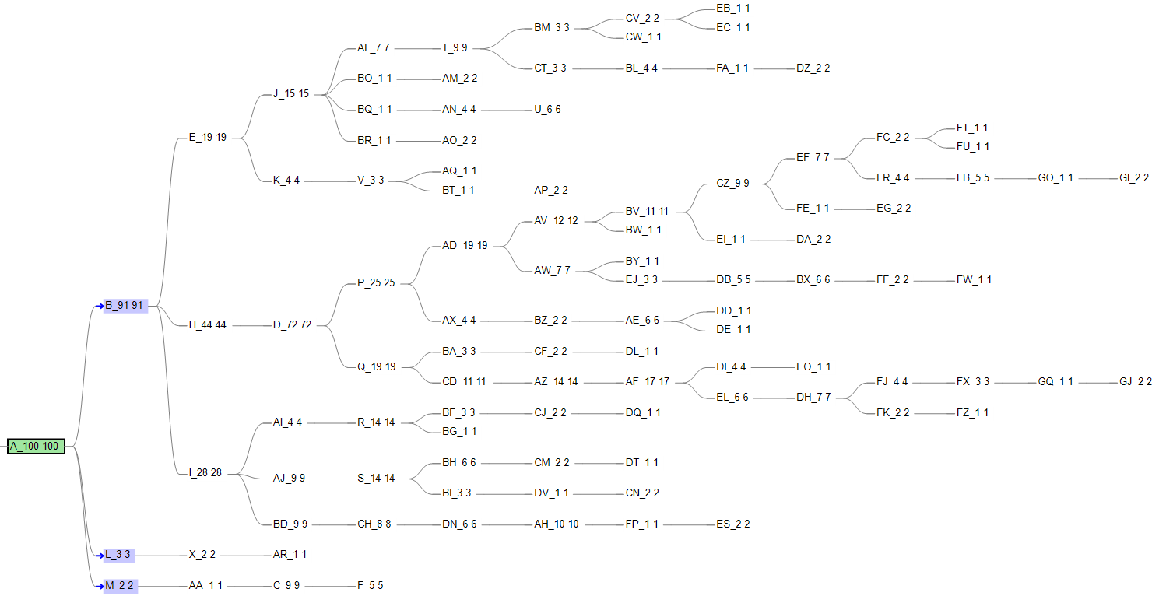

Matrix Comparison Score: 0.9898299

SCITE PLUS:

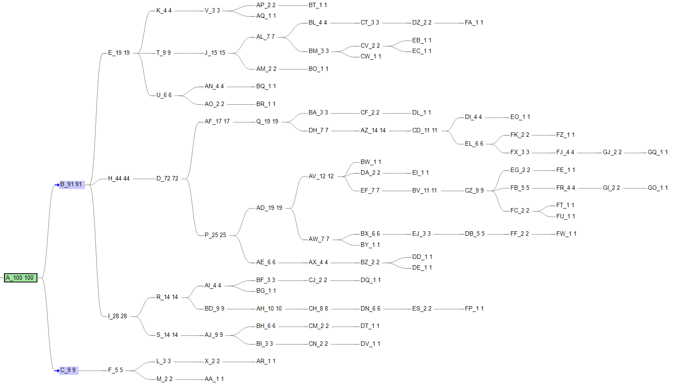

Matrix Comparison Score: 0.99519

CASE 2: Blander Cancer Data – 44 Single Cell

## SCITE:

A single Line

## SCITE JAVA:

## SCITE PLUS: